**Razorpay Payment Gateway**

**Test API key**

Key Id: rzp_test_kPow8NV72MMXWb

Key Secret: Aw0QaMRJpnX3aBWZem2WZomN

Webhook Secret: razorpaysecret

**Live API key**

Key Id: rzp_live_Rd4mu1zo1ysKfw

Key Secret: LOD0LsrcZSUMHppMioDqkjOZ

**Display Qualification Dropdown Values in Volunteer Registration Form**

Please add “Employees > Configuration > Skill Types > New ” Skill Type=Qualification and add skills to display “Qualification” dropdown in Volunteers Registration Form,

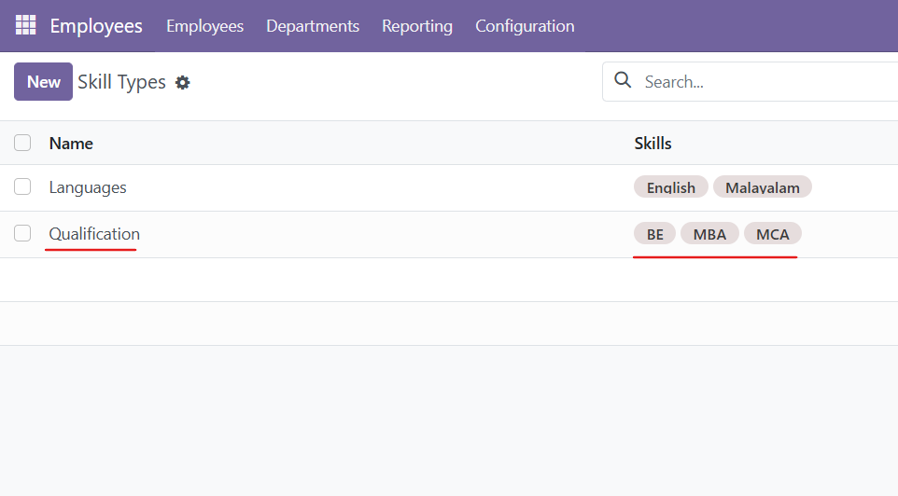

**Update Models**

Provide permission to below models

**EVENTS**

account.payment

crm.team

crm.team.member

account.move

account.move.line

account.account

account.journal

product.product – Read

product.template – Read

sale.order.line

event.registration

**CAMPAIGN**

volunteer.campaign

volunteer.campaign.payment

**COMMON**

uom.uom

account.tax.group

account.tax

account.tax.repartition.line

account.payment.register

account.payment.method.line

account.payment.method

mail.template

ir.actions.report

mail.mail

res.partner.category (res_partner_category group_user)

**Modified Modules**

Custom_website

Custom_event

Event

Event_sale

Payment

Volunteers_donors_non_profit

Website_event

Website

Account

- Enable Discounts and Loyalty program from Settings

**Add company logo in the event ticket**

Modify this file.

* event>report>event_event_templates.xml > event_report_template_full_page_ticket

**Update Event Registration**

Modify this file cigi\addons\event_sale\models\event_registration.py. And update the _compute_registration_status method

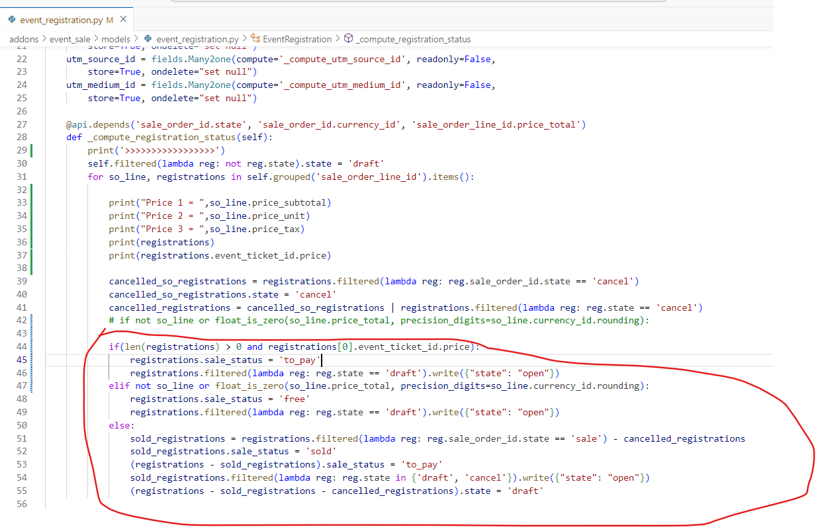

@api.depends('sale_order_id.state', 'sale_order_id.currency_id', 'sale_order_line_id.price_total')

    def _compute_registration_status(self):

        print('>>>>>>>>>>>>>>>>>')

        self.filtered(lambda reg: not reg.state).state = 'draft'

        for so_line, registrations in self.grouped('sale_order_line_id').items():

            print("Price 1 = ",so_line.price_subtotal)

            print("Price 2 = ",so_line.price_unit)

            print("Price 3 = ",so_line.price_tax)

            print(registrations)

            print(registrations.event_ticket_id.price)

            cancelled_so_registrations = registrations.filtered(lambda reg: reg.sale_order_id.state == 'cancel')

            cancelled_so_registrations.state = 'cancel'

            cancelled_registrations = cancelled_so_registrations | registrations.filtered(lambda reg: reg.state == 'cancel')

            # if not so_line or float_is_zero(so_line.price_total, precision_digits=so_line.currency_id.rounding):

            if(len(registrations) > 0 and registrations[0].event_ticket_id.price):

                registrations.sale_status = 'to_pay'

                registrations.filtered(lambda reg: reg.state == 'draft').write({"state": "open"})

            elif not so_line or float_is_zero(so_line.price_total, precision_digits=so_line.currency_id.rounding):

                registrations.sale_status = 'free'

                registrations.filtered(lambda reg: reg.state == 'draft').write({"state": "open"})

            else:

                sold_registrations = registrations.filtered(lambda reg: reg.sale_order_id.state == 'sale') - cancelled_registrations

                sold_registrations.sale_status = 'sold'

                (registrations - sold_registrations).sale_status = 'to_pay'

                sold_registrations.filtered(lambda reg: reg.state in {'draft', 'cancel'}).write({"state": "open"})

                (registrations - sold_registrations - cancelled_registrations).state = 'draft'